Algebra I Class Syllabus & Expectations

Contact Information: Becky Davis
Email: becky_davis@bismarckschools.org
Phone: 323-4650 ext. 5632
Website: http://www.ocelotmath.weebly.com
Grading Scale:
- Proficiency scales for each standard are linked in PowerSchool
  - 4—extended knowledge and understanding
  - 3—proficient
  - 2—partially proficient
  - 1—beginning understanding

- Students will earn behavior grades in the categories of Respect and Responsibility
  - 3—meets expectations
  - 2—progressing
  - 1—needs improvement
Letter Grade Conversion:
Proficiency Level | Letter Grade
3.00 - 4.00 | A
2.50 – 2.99 | B
2.00 – 2.49 | C
1.00 – 1.99 | D
Below 1.00 | F
High School Credit:
- Students will receive high school credit for Algebra 1.
- Your grade will count towards your high school GPA.

Class Content/Standards:
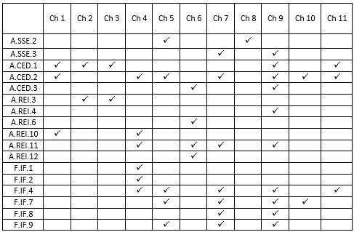
- The table at the right shows which standards are covered throughout the year and during which chapter they will be covered.
- Algebra builds on itself so some standards will be covered throughout the year. That means proficiency will change, depending on what part of the year it is covered.
  - For example: Proficiency on A.CED.2 in the beginning of the year (ch. 1) looks different than proficiency on the same standard towards the end of the year (ch. 10 & 11)
Absences and Missing Work:
- Please check with me if you need to make up missing work.
- Ask for work ahead of time, if possible.
- I am available most days before and after school for assistance.

Homework:
- Students will usually be allowed time to get started on assignments during class but they will be expected to complete assignments at home.
- Homework is very important in Algebra as that is the way you will get the practice needed on the topics being covered.
Required Materials:
- CALCULATOR
- Pencils
- Pens
- Math notebook

